How to Access ACCOPS

Click the “Start” button and search for “Remote Desktop Connection”

In the window that pops up, type in “ts.freight.fedex.com” and hit “Connect”

Please enter in your login and LDAP password. You want to Log into “ARFW”.

Your login will be in the following format: “FXL0000”, with F being your first initial, L being your last initial, and 0000 being the last 4 numbers of your FedEx Employee ID.

Once it connects, you will see a lot of pop up windows indicating “IP ADDRESS NOT FOUND”. This is normal, so just close these windows when they appear. You will also get a prompt about printer selection; feel free to close this.

Click “Start”, “Programs”, “Operations”, and “Customer Maintenance”. You will see a popup window indicating “IP ADDRESS NOT FOUND”. This is normal, so just click OK.

The rest of the steps can be found in KB 14342.

http://helpdesk-fedex.custhelp.com/app/answers/detail/a_id/14342/kw/14342

Please note, our process for logging in to ACCOPS is different than displayed in the KB.

- Click Customer Search
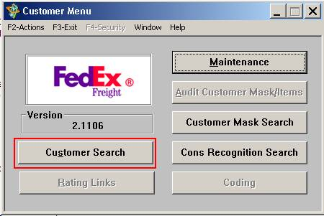
- Enter the LTL account number in the “Account” field. Do NOT press “Enter”. Click the small profile of a face icon.
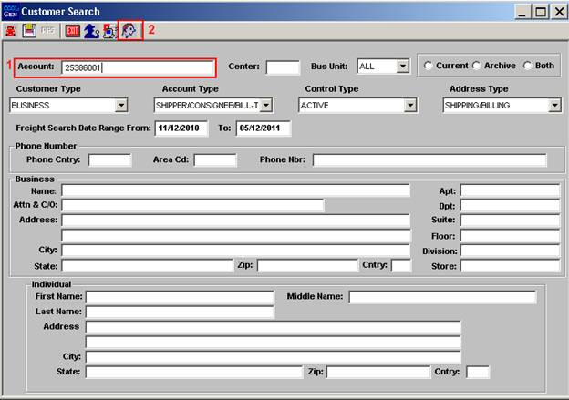
If you do not know the account number
  - Enter the company name in the “Name” field and press “Enter”.
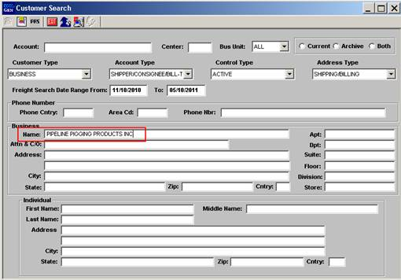
  - If this customer has an LTL account a pop up window with the search results which includes the companies Freight Account number will appear. Return to the Customer Search screen and follow the steps using the Account number.
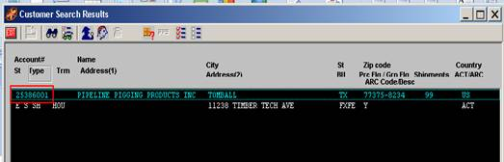
- The “Cust Prof” screen will provide information about the account including the Ship from address, Account type, Account status and Cash Only status.
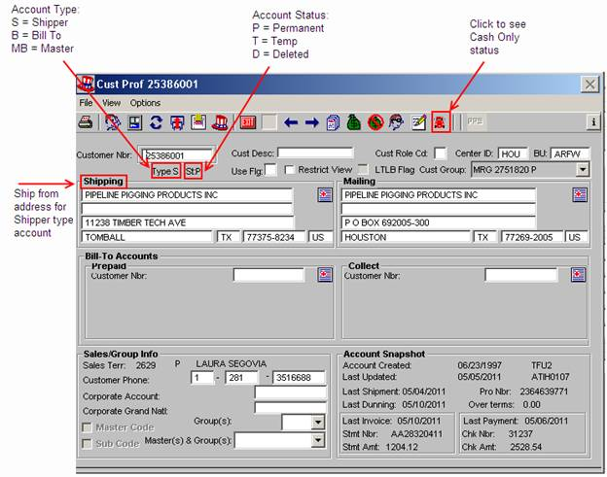
 | Be advised that CASH ONLY in LTL Freigt is NOT the same as CASH ONLY in Express. Usually it means that the account is new and no shipments have been processed using the account. Call the Freight/LTL helpdesk at 866-756-3590 and advise them of the issue. They can remove the CASH ONLY flag is possible.
- The Shipping address and the Mailing address found the “Cust Prof” screen must match what is entered into the FSM “Add Freight Account” screen referred to here. The Mailing address in ACCOPS is the Billing Address in FSM.
